TECHNOLOGICAL REVOLUTION IN THE WORLD OF SPORTS

"Information is the oil of the 21st century, and analytics is the combustion engine."

~ Peter Sondergaard

The word "Sport" comes from the Old French desport meaning "leisure", with the oldest definition in English being "anything humans find amusing or entertaining".

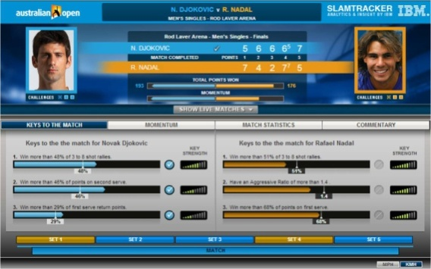Sports are an integral part of today’s world, in business terms- it being a billion dollar industry, generates huge amount of capital all over the world, on personal terms- being part of a sport, offers people different lessons of life including- sportsmanship, a never say die-attitude, having positive outlook on life -no matter what, trying and giving your best and above all nothing is impossible. Nowadays, technology plays an important role in modern sports. Sports science is a widespread discipline that is being applied in various sports. The Data generated and collected in various aspects of sports is being analyzed and utilized to gain an edge in improving performance in every aspect of a particular sport, to create a better spectacle. Let’s discuss some of the major achievements and improvements that have been made in sports courtesy of the new technologies involved:

(1)Germany’s 2014 Football World Cup Win:

The team partnered with German software giant SAP AG to create a custom match analysis tool that collects and analyzes massive amounts of player performance data.The tool, called Match Insights, analyzes video data from on-field cameras capable of capturing thousands of data points per second, including player position and speed.

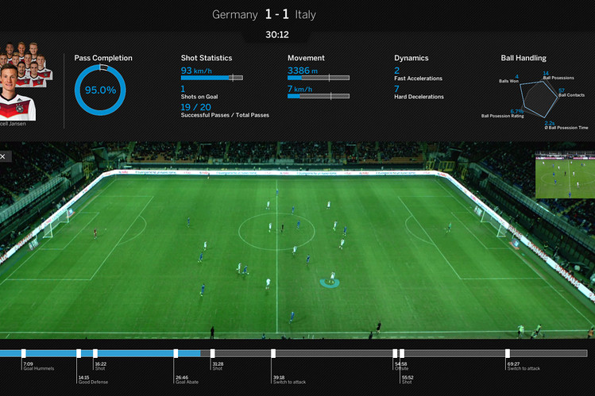

(2) Tennis(IBM Slam Tracker): This technology aggregates and publishes a variety of statistics- from a competitor's point-by-point probability of winning the match to his/her opponent's.

(3)Prozone: The system by sports analytics provider prozone tracks 10 data points per second for every player, or 1.4 million data points per game. The system is also used to monitor 12,000 soccer matches around the world, which are all analyzed using automated algorithms as well as manual coding. Arsenal Football club based in London, England has invested millions in this technology.

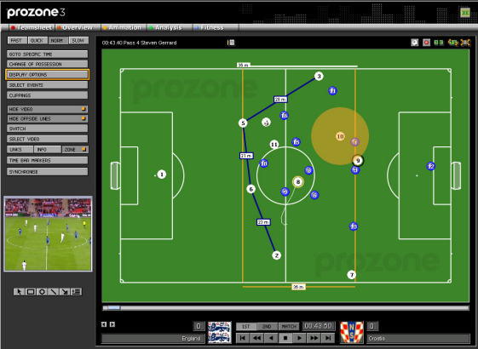

These and many other technologies are being currently being used in the field of sports to better analyze the strengths and weaknesses of a sportsperson and the scope of further improvement in that individual and in the sport itself.

I hope our nation ‘INDIA’ uses its financial power, so tools mentioned above like Match Insights etc are introduced for the betterment of our group of players and for the advancement of our nation in every sport.

REFERENCES

<https://en.wikipedia.org/wiki/Sport>

<http://blogs.wsj.com/cio/2014/07/10/germanys-12th-man-at-the-world-cup-big-data>

Submitted by: ASHISH SONI

M.C.A(SEM-3)